**Madiha Aimon Tappal**

[**madihaaimon@gmail.com**](mailto:madihaaimon@gmail.com)

**Day -4**

**Data Engineering Batch – 1**

**Create database :**

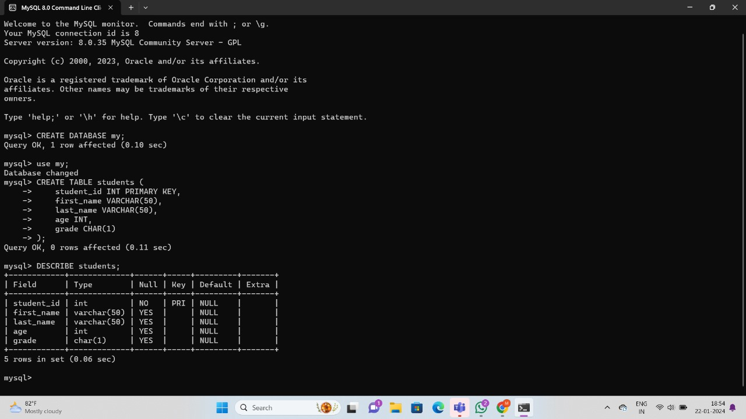

**Insert:**

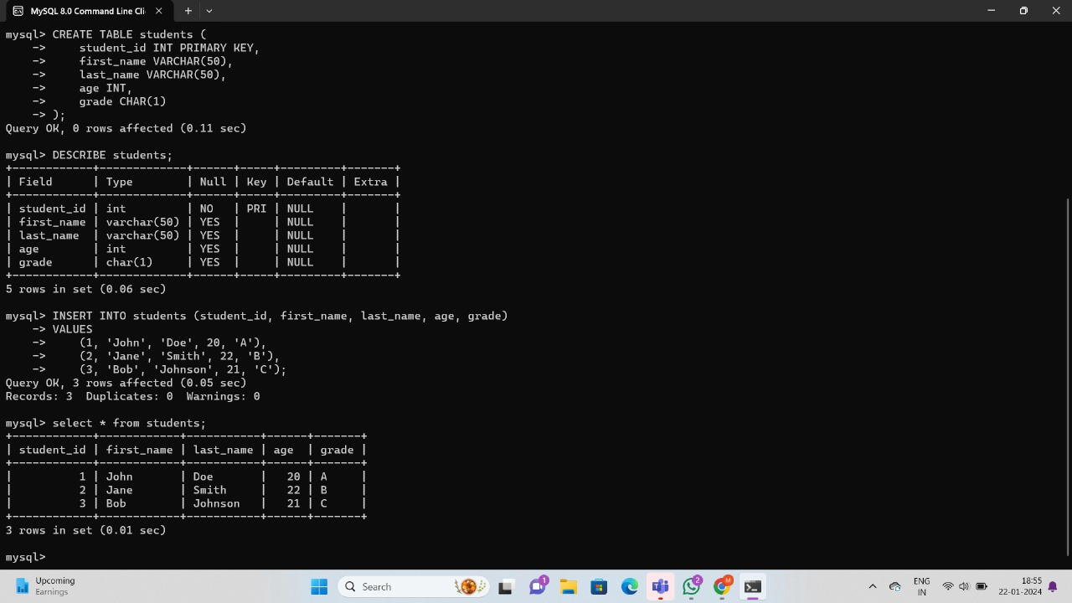

**Update:**

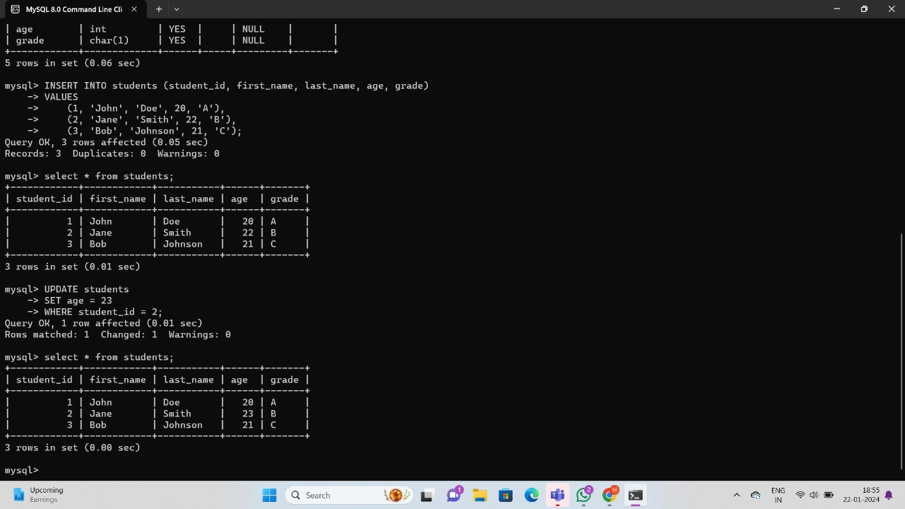

**Delete :**

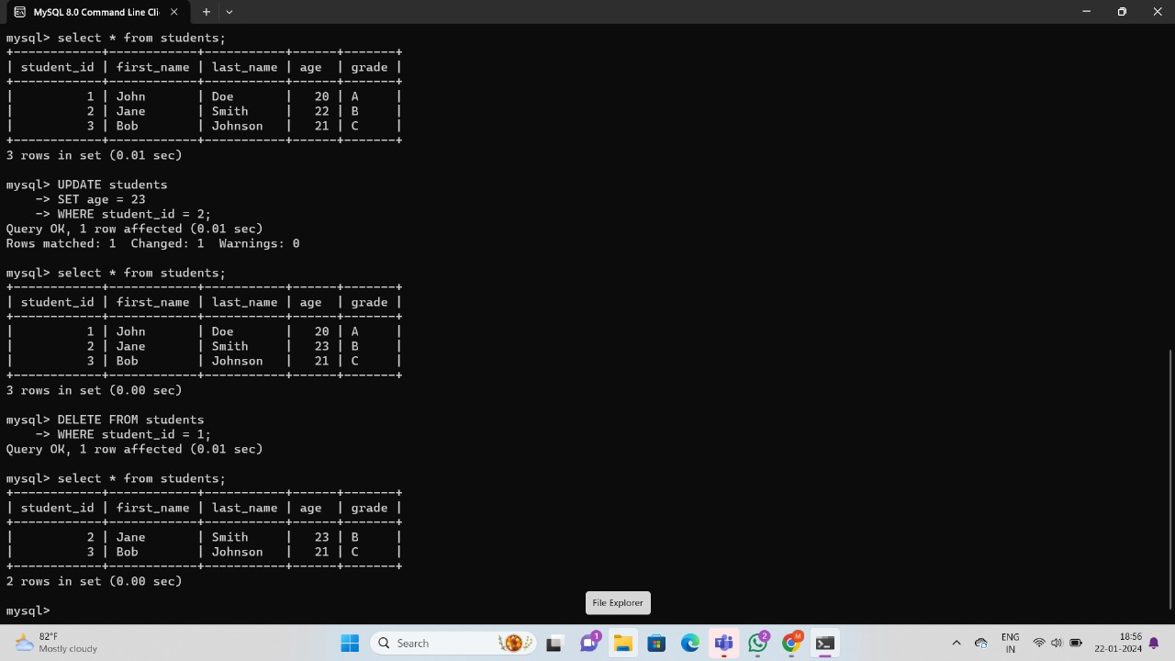

**Retrieving Specific Attributes:**

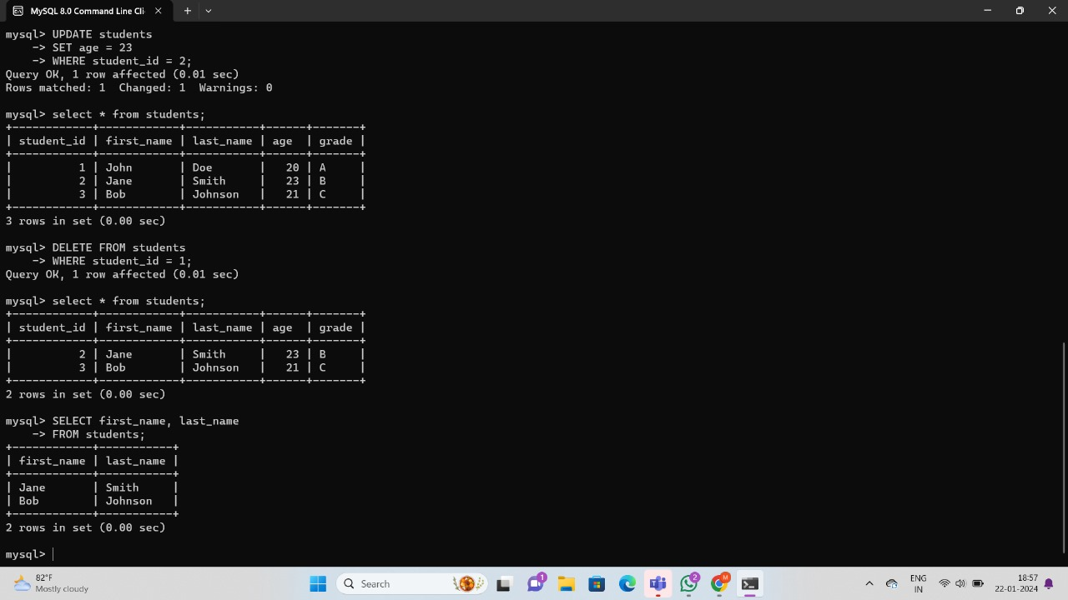

**Retrieving Selected Rows:**

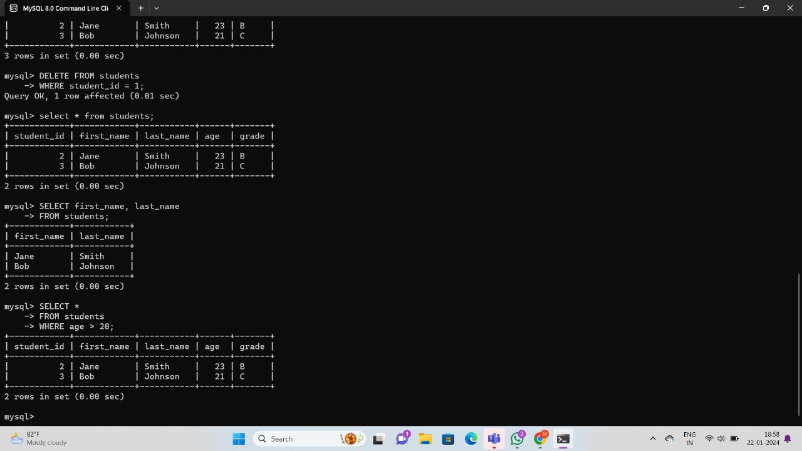

**Using IN, DISTINCT, AND, OR, BETWEEN, LIKE:**

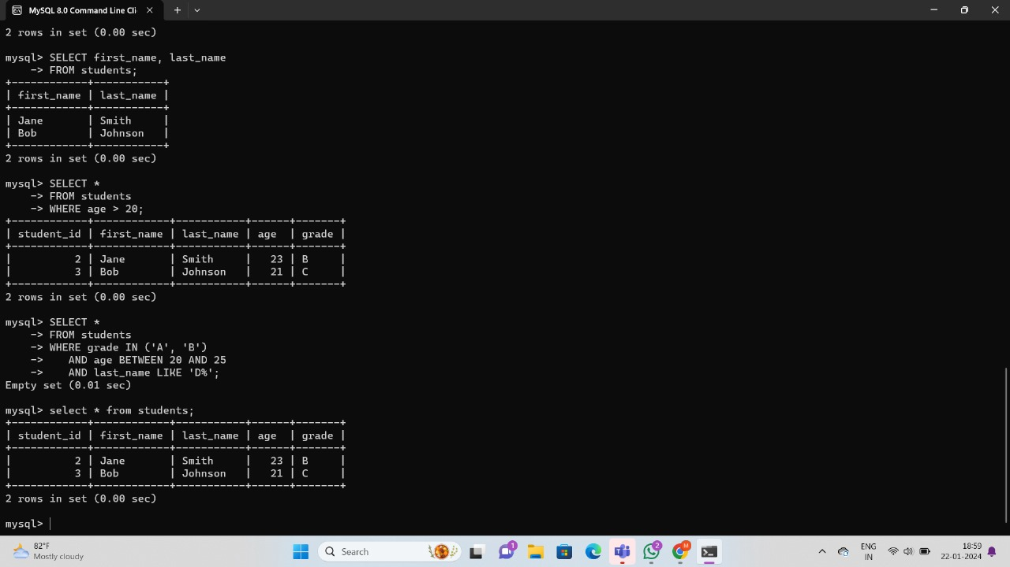

**Using Aliases:**

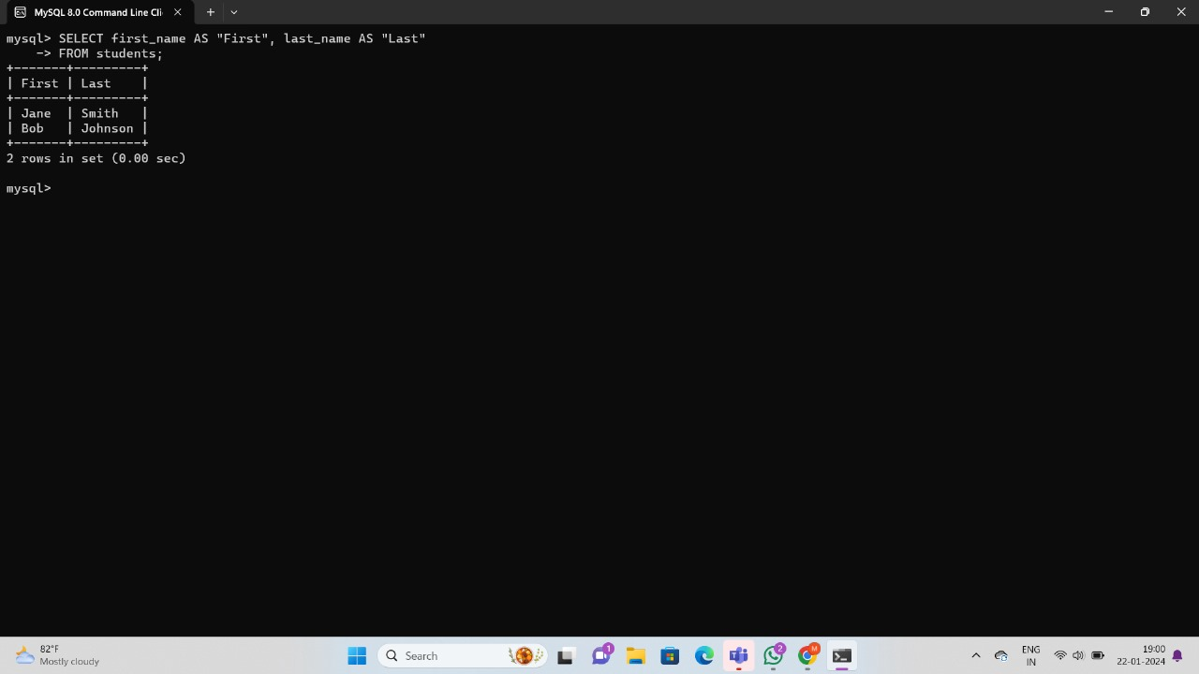

**Implementing Data Integrity:**

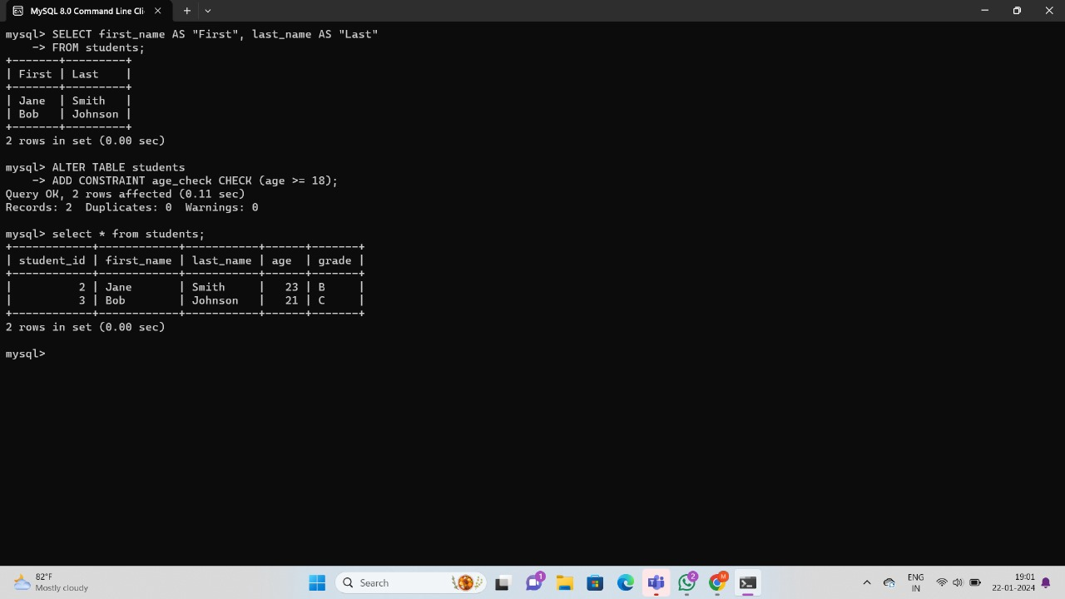

**Using Aggregate Functions:**

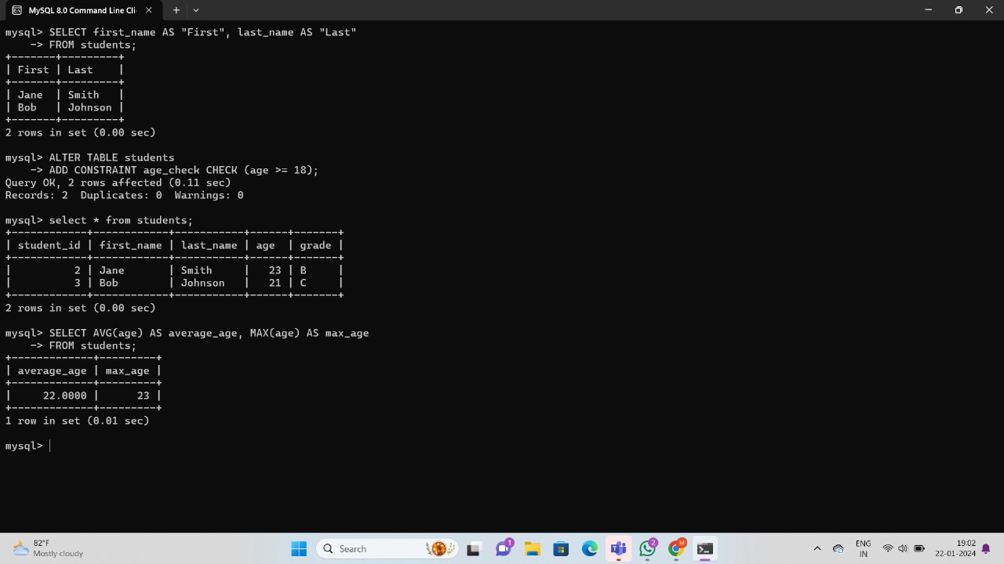

**Grouping Data:**

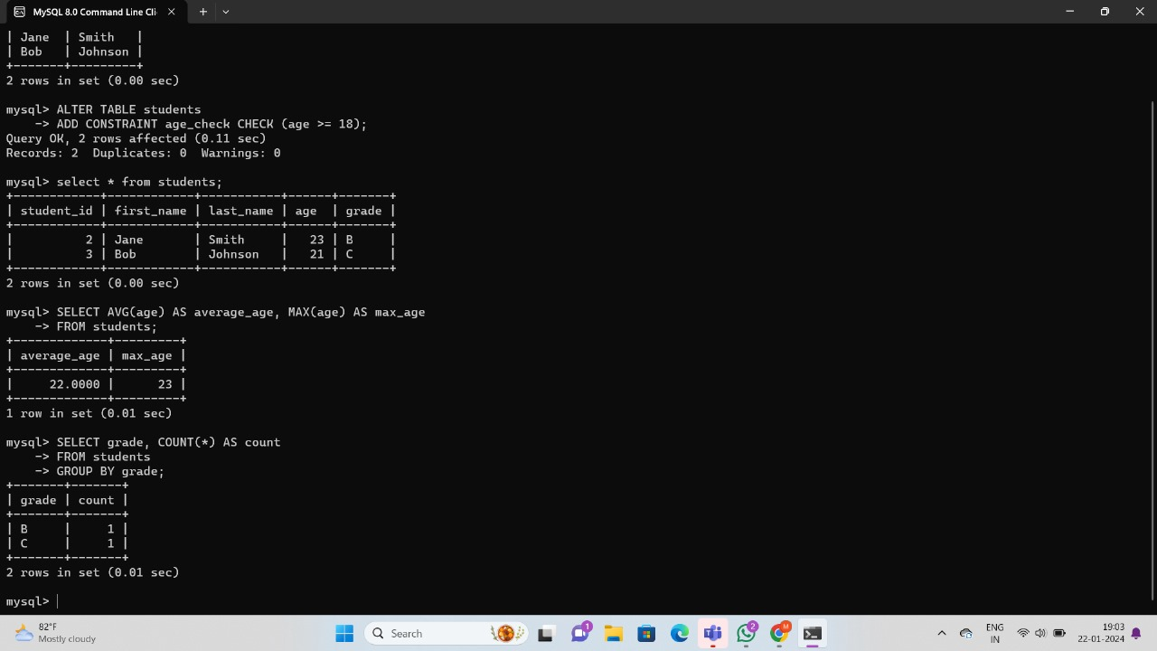

**Filtering Data using SQL Queries:**

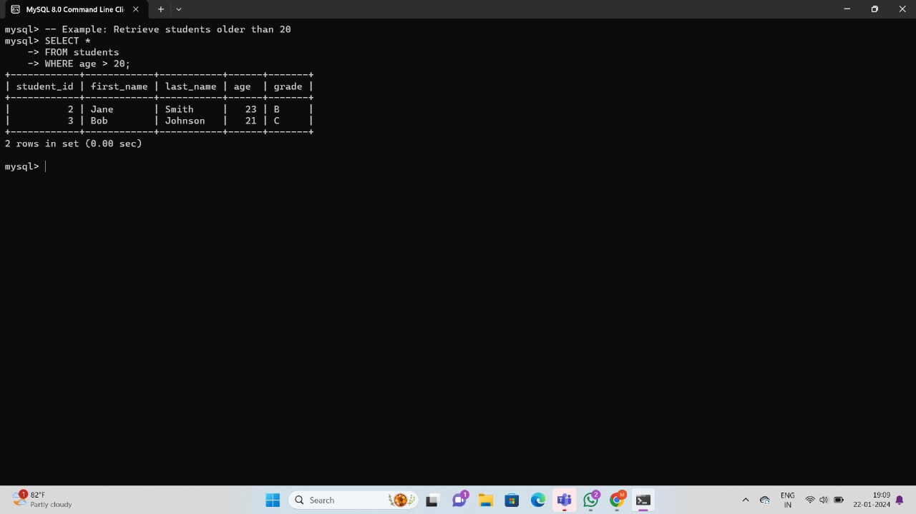

**Total Aggregations using SQL Queries:**

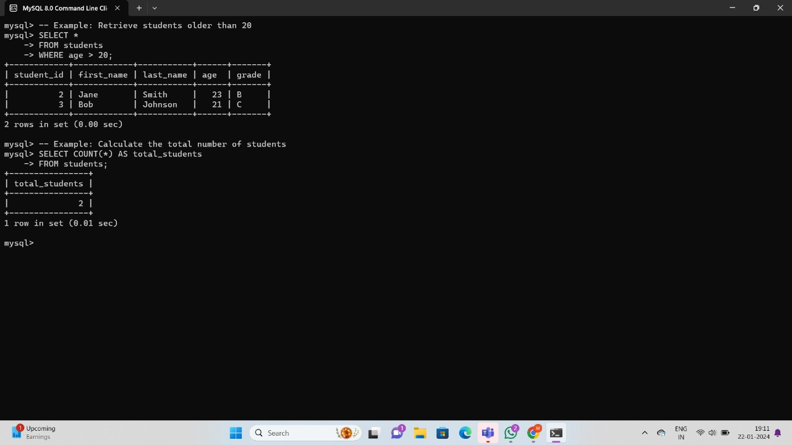

**Group By Aggregations using SQL Queries:**

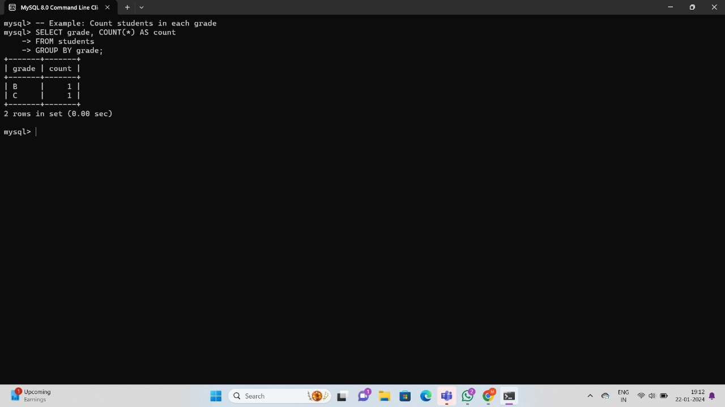

**Order of Execution of SQL Queries:**

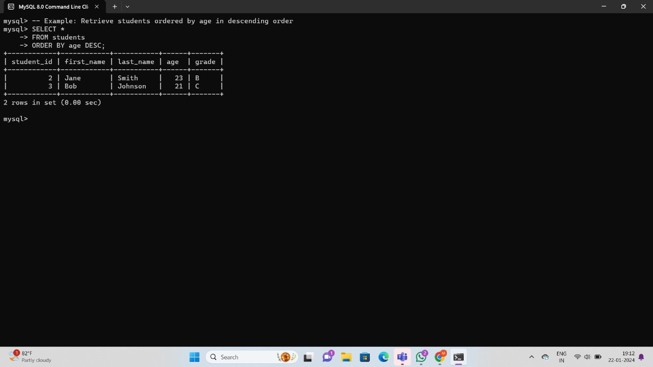

**Group and Filter Data**

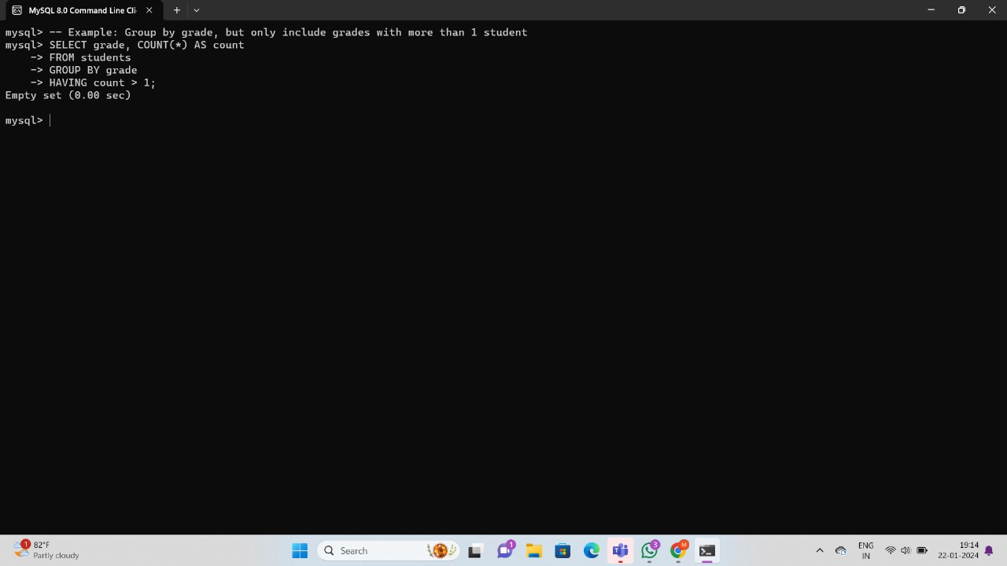

**Filter Data based on Aggregated Results using Group By and Having:**

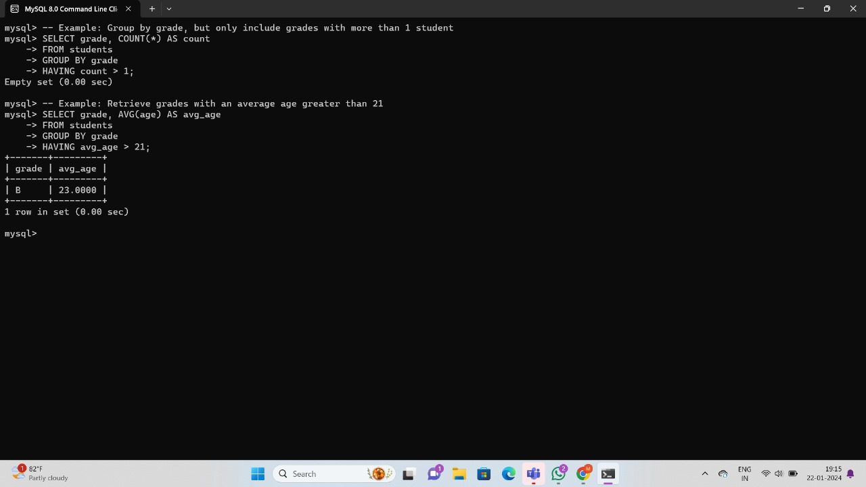

**Inner Join:**

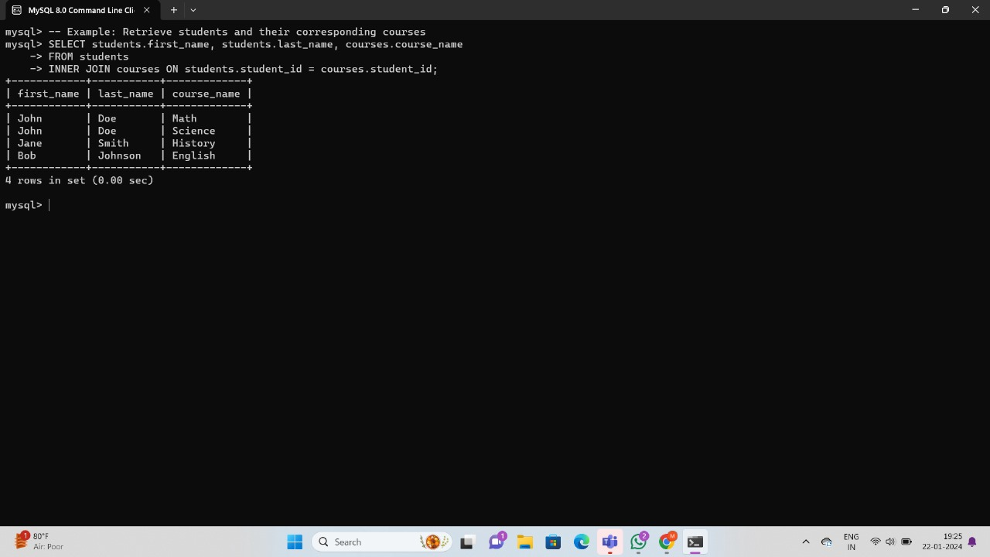

**left join:**

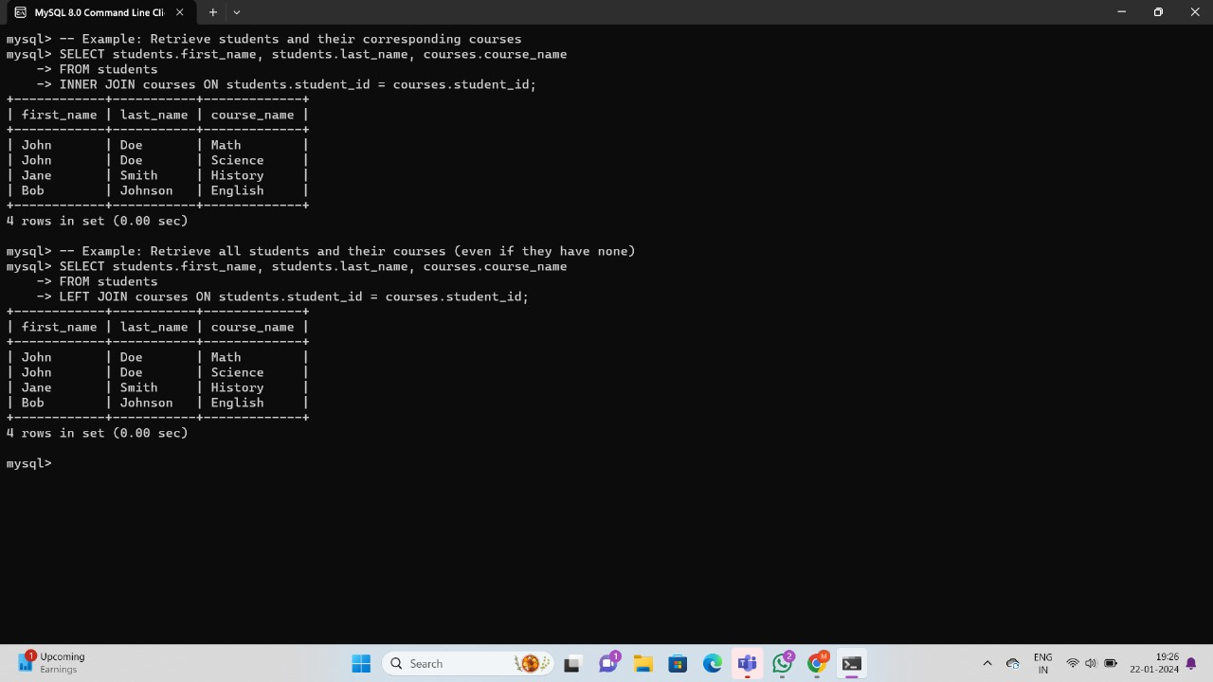

**Right join:**

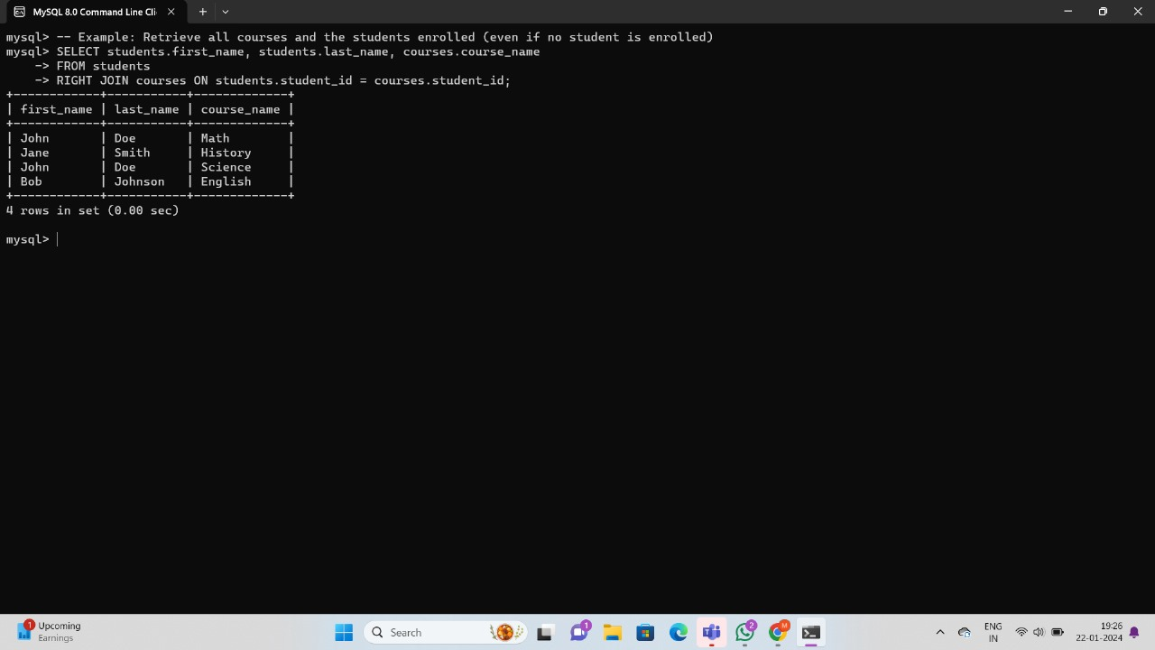

**FULL OUTER JOIN**

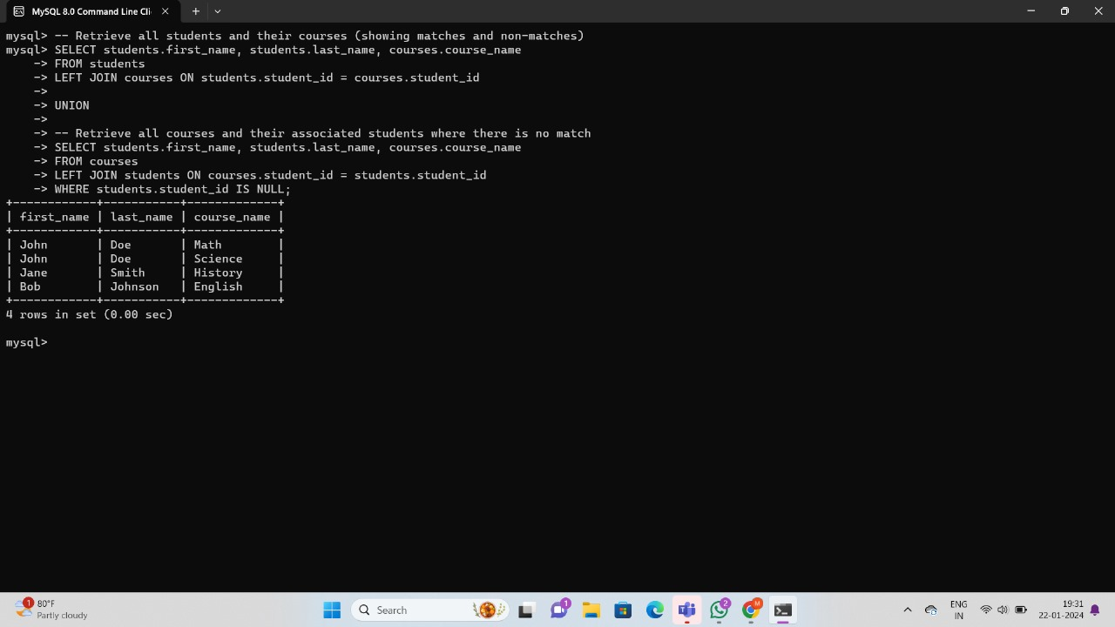

**Cross join**

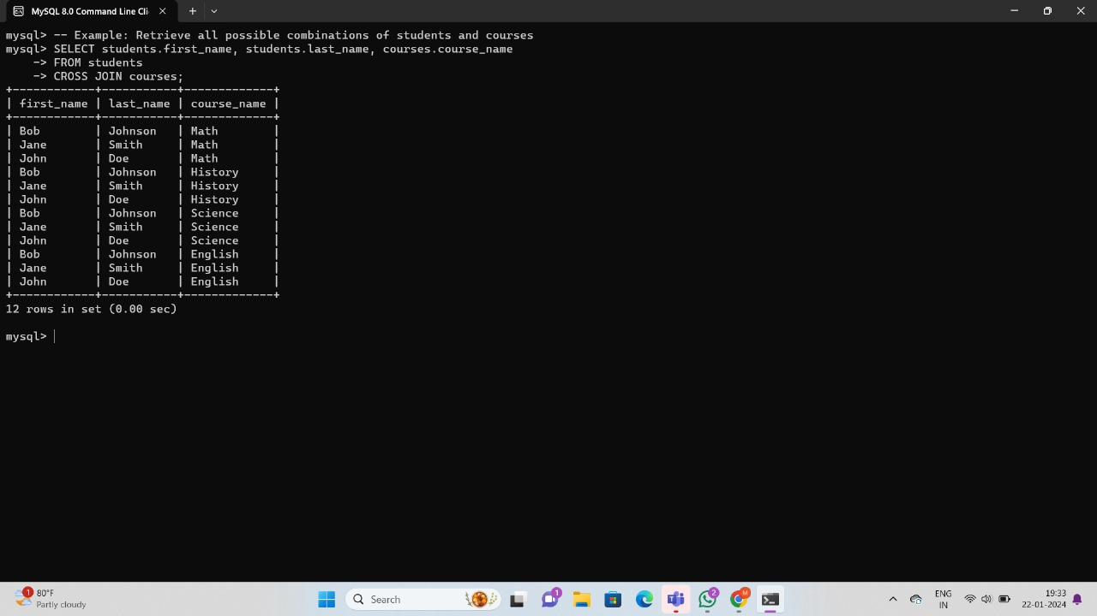

**Subquery**

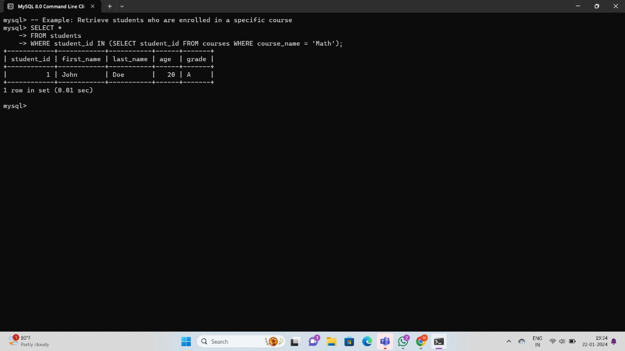

**EXISTS**

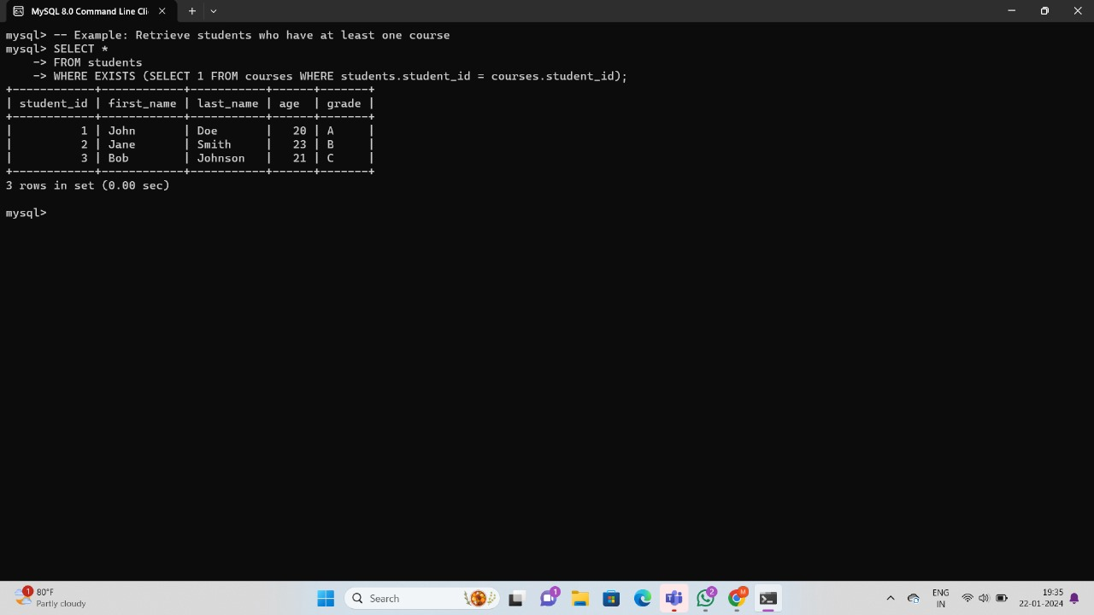

**ANY, ALL**

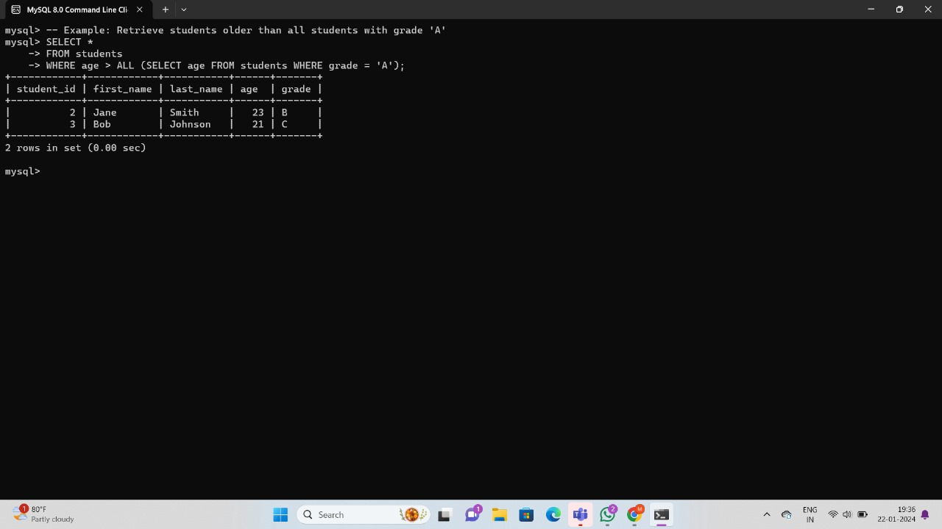

**Nested Subqueries**

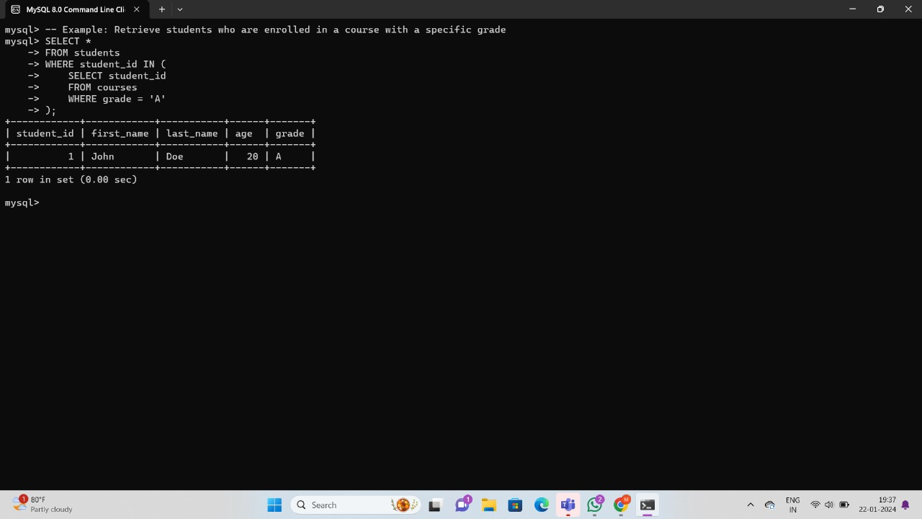

**Correlated Subqueries**

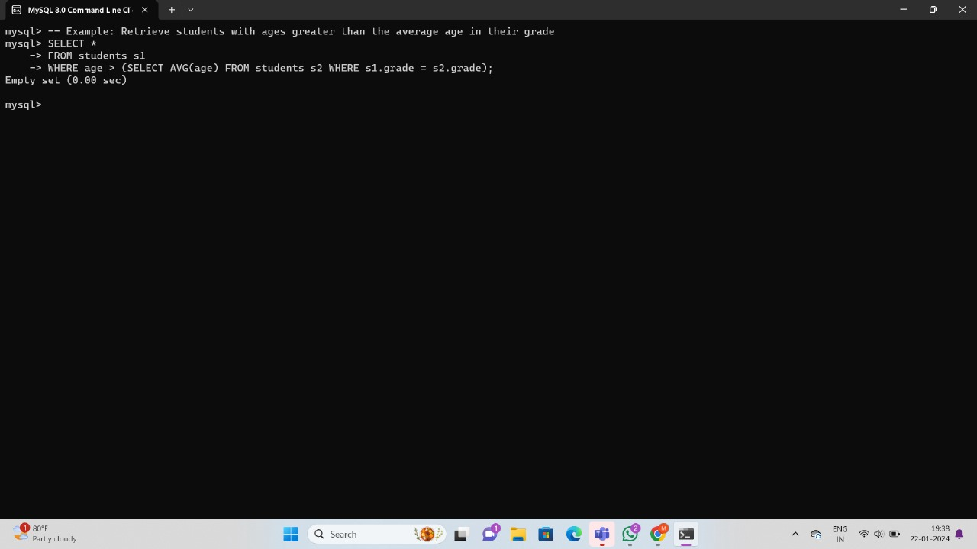

**Using UNION, INTERSECT, EXCEPT**

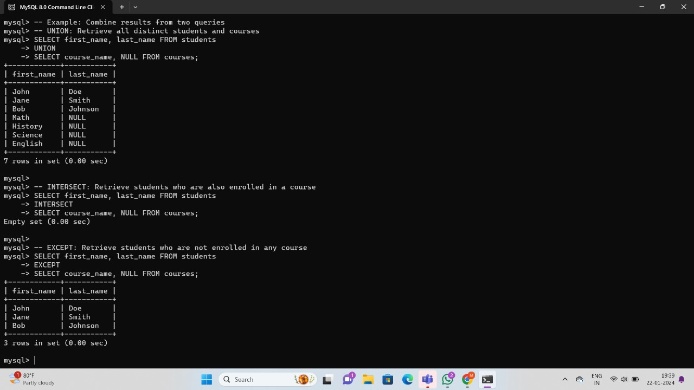

**Merge statement**



**Example Queries with Mathematical Functions: -**

#### **Calculate the Average Age of Students:**

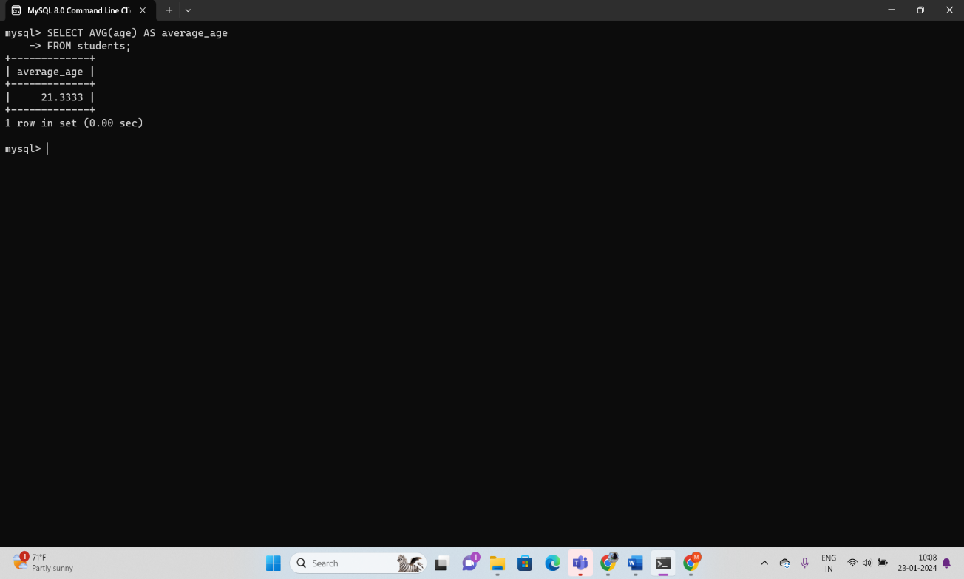

#### **Round the Average Age:**

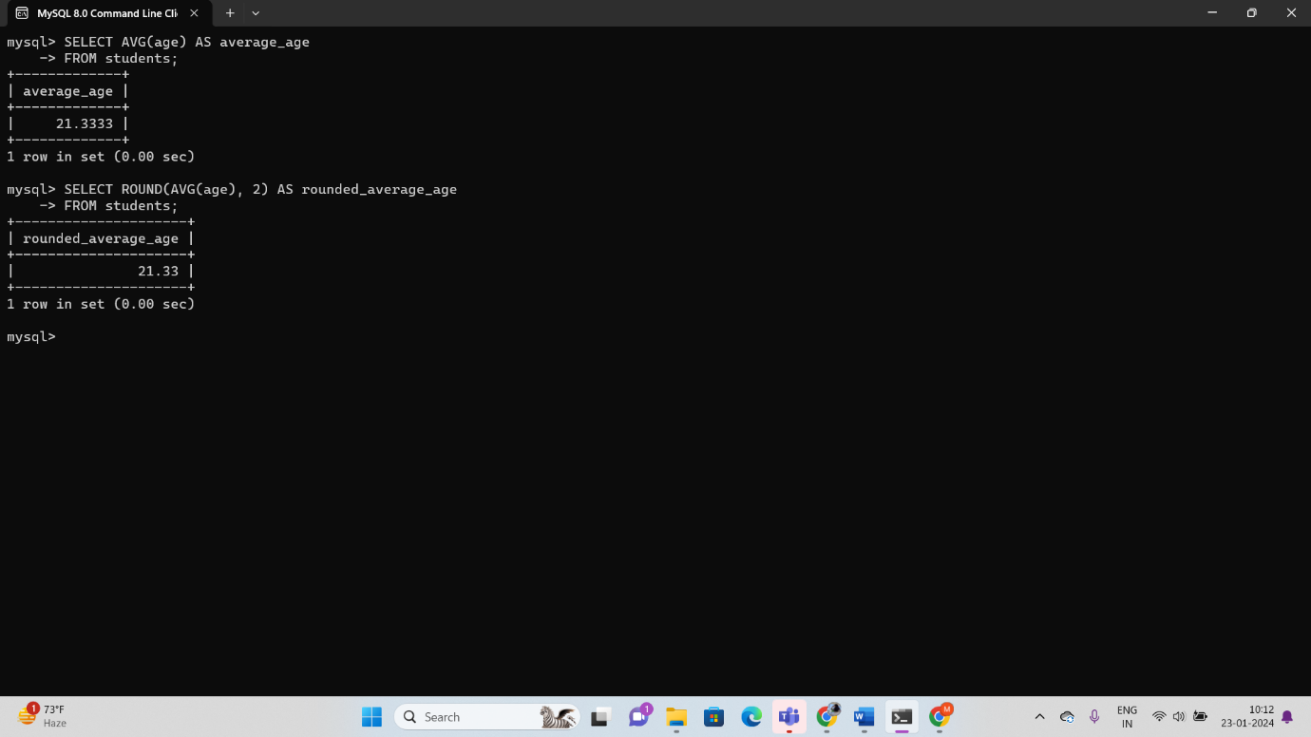

#### **Calculate the Square Root of the Age:**

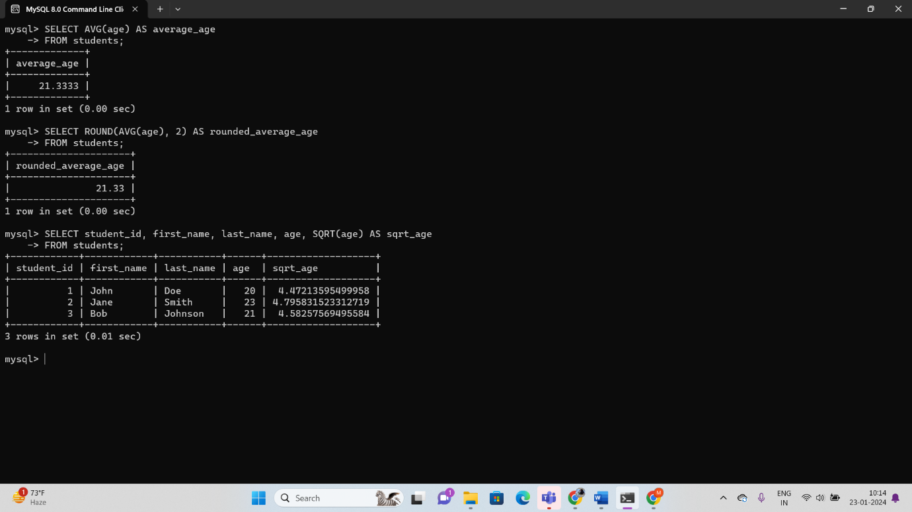

#### **Generate Random Grades for Students:**

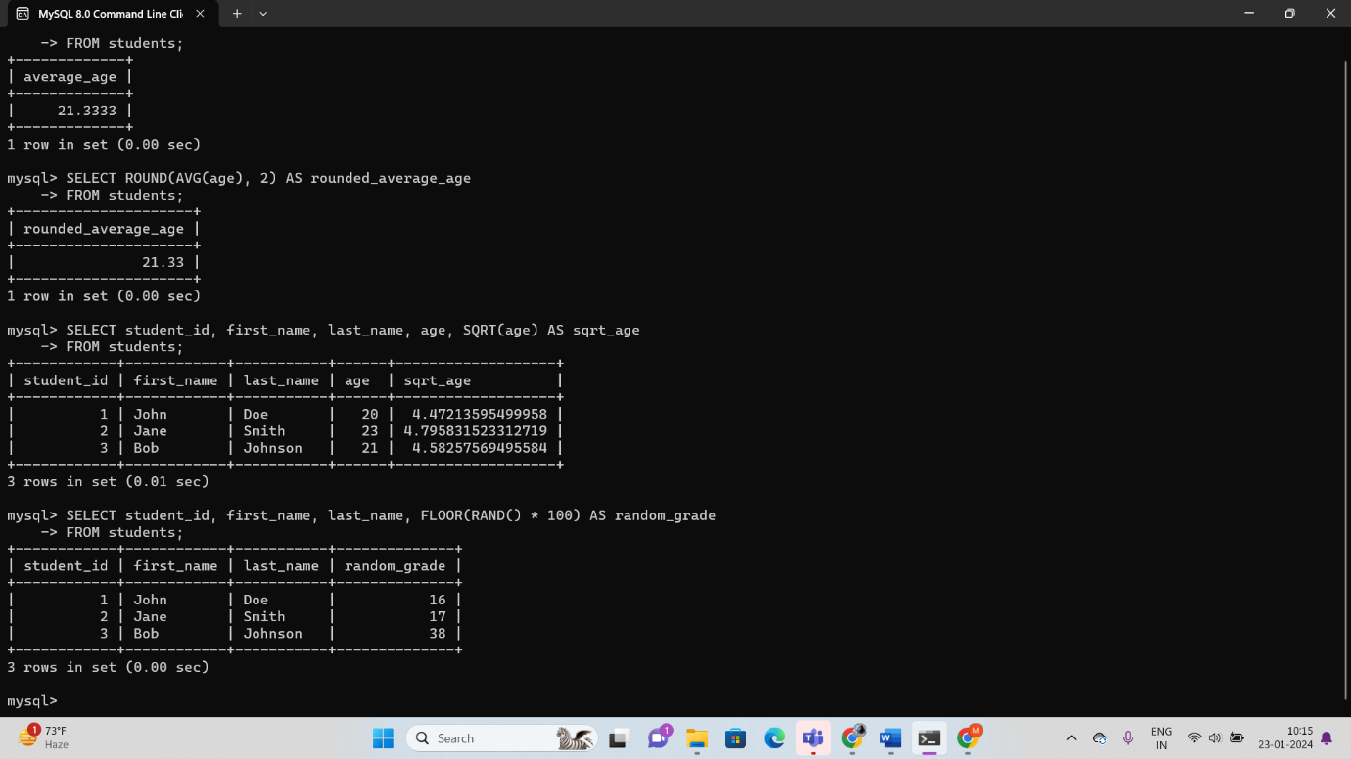

### Comparison Operators:

#### **Equal to (=)**

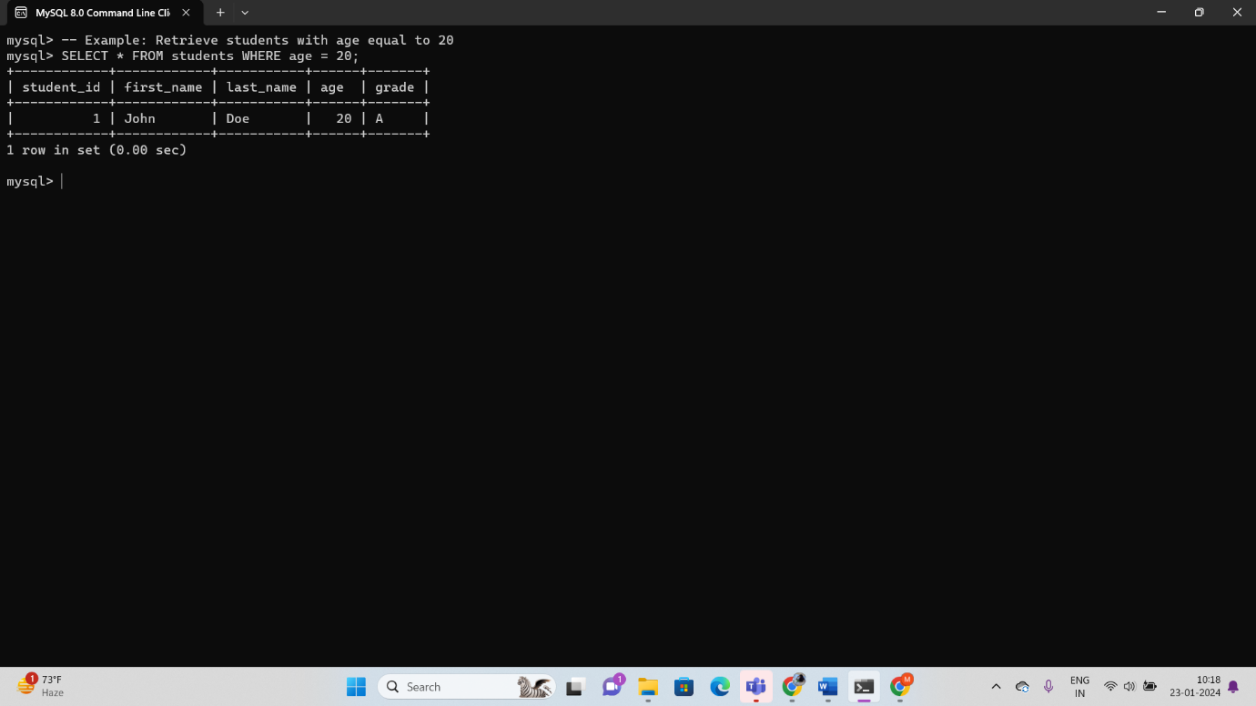

#### **Not equal to (<> or !=)**

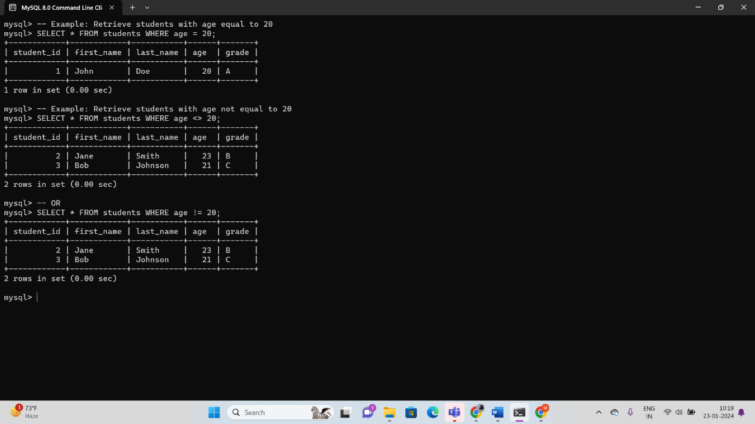

#### **Greater than (>)**

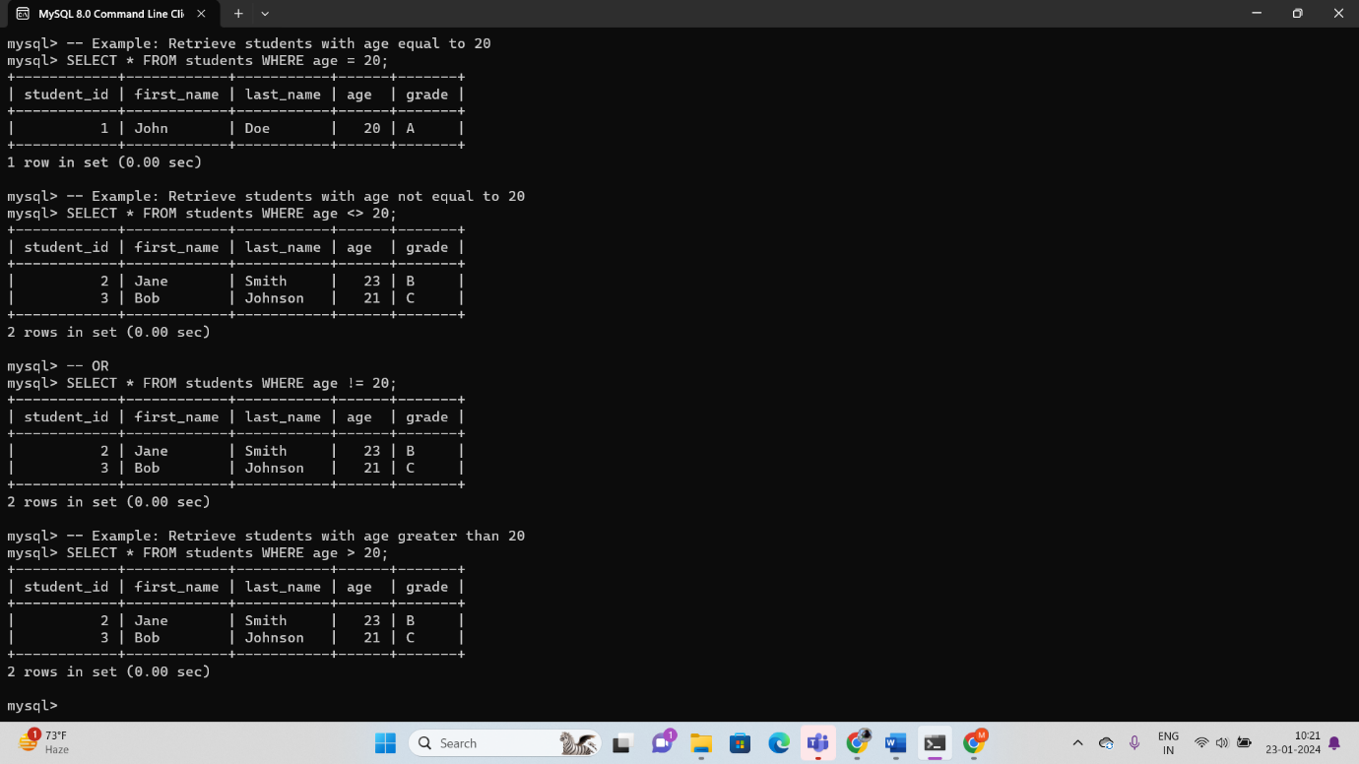

### Logical Operators:

### 

**string functions: -**

### Concatenation:

### 

### Length:

#### **Get the length of a string:**

### 

### Upper and Lower:

#### **Convert string to uppercase or lowercase:**

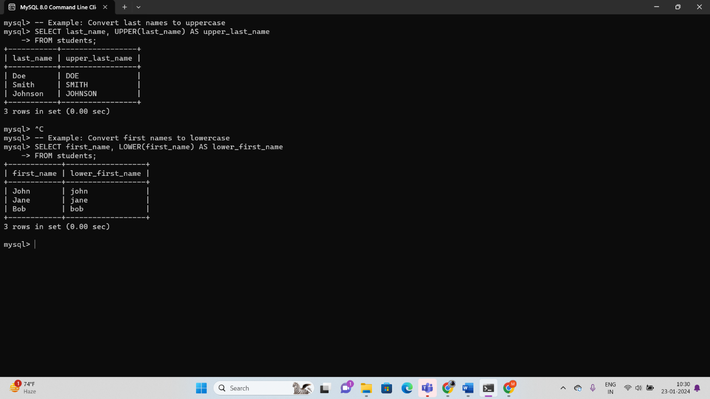

### Replace:

### 